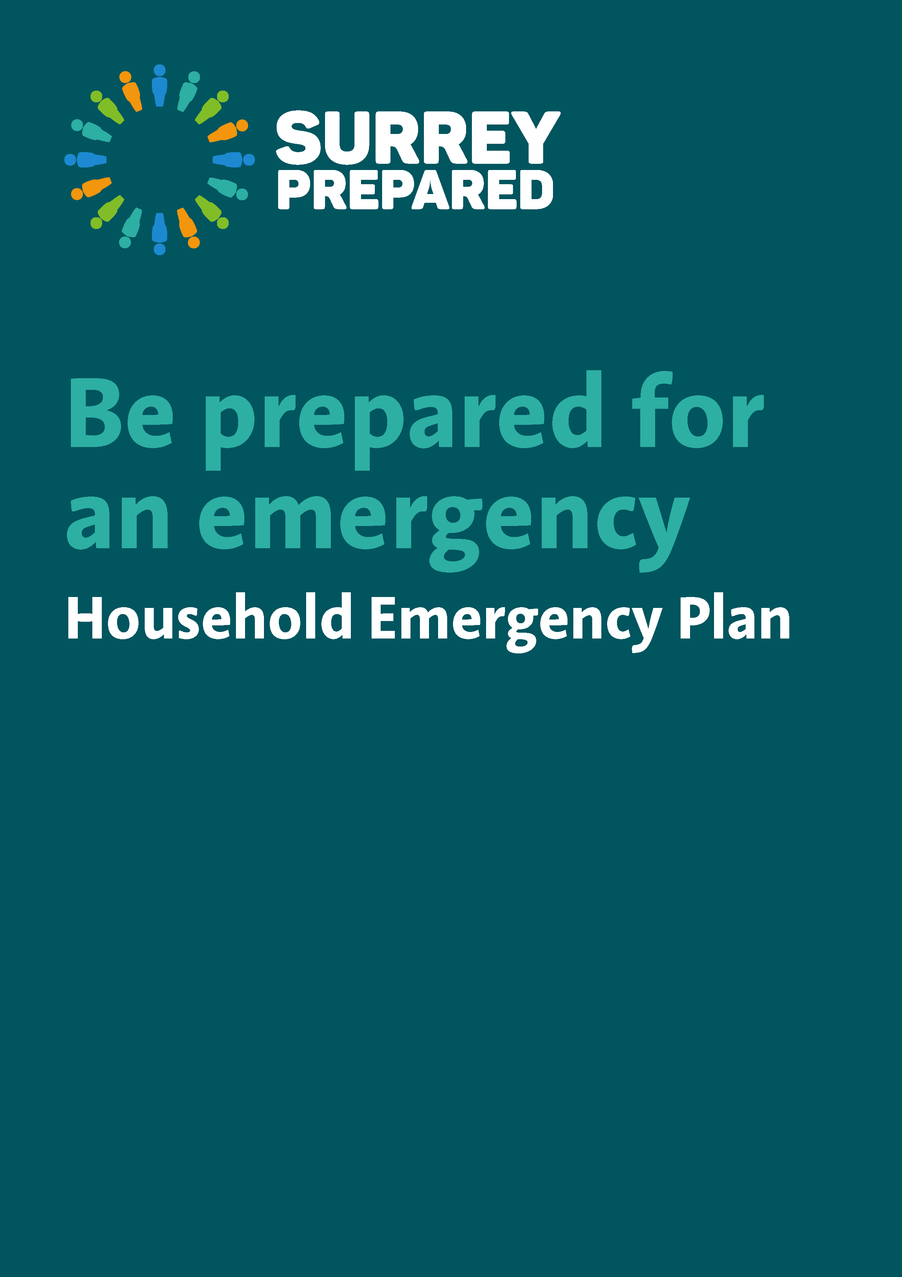

Why should you prepare for emergencies?

Emergencies can be unexpected and even if we think that they won’t affect us, we never know what might happen – even down to an unexpected long traffic delay or power cut for example.

This guide outlines simple steps to help you prepare. A few minutes thinking about it now could make a big difference in helping to keep you and your family safe later. You should ensure that everyone in your household knows about the plan and what to do in the event of an emergency.

There are a number of different types of incidents that you may be affected by, but the risks will be different throughout Surrey. Take some time to consider the potential hazards and what action you and your family can take to minimise danger to life and property.

See the Surrey Prepared pages on the Surrey County Council website or contact community.resilience@surreycc.gov.uk

If you or someone else is in imminent danger of harm or to life call 999 and choose from Fire, Ambulance or Police.

In the event of a fire, Get out, Stay out and call 999
How to prepare yourself for an emergency

Home emergency preparedness checklist
- Think of how you would escape quickly in the event of fire or gas leak. Make especially sure the escape route is kept clear of things that might cause falls – but avoid trip hazards on any floor or the stairs in any case at all times.
- Put together an emergency grab bag of those essential items and documents that you might need and are not easily available to buy if you have to leave your home for a day or longer – medication, insurance documents, and identity documents, for example.
Emergency Grab bag
- Essential/prescribed medication or details of prescriptions, any medical equipment
- Basic essentials for babies and toddlers (perhaps including a favourite toy)
- Basic essentials for pets
- Mobile phone (and charger if possible)
- Spare set of clothing
- House and car keys
- Copy of this booklet/plan
- Small amount of cash
- (Wind-up) torch and spare batteries

- Discuss with your family to agree places where you could meet if you cannot get to your home and how you will stay in contact. A friend, relative or neighbour could be included in this as a safe place to meet or stay, or as an emergency contact.
- If you have children, teach them how and when to call emergency services.
- Find out if neighbours might need your help if they might be less able.
- Check who your regional power distribution company is at powercut105.com
Power, gas and water loss
For extra help in power cuts, join the Priority Service Register if you have a young baby, health care requirements or sensory or mobility limitations, or are an older person. Check your electricity distribution company and eligibility at Powercut105.com or by calling UK Power Networks on 0845 601 4516 .
A few areas are covered by SSE Networks on 0800 294 3259. If eligible also contact your billing companies for electricity, gas and water for help and support.
Handy hints
• It’s useful to have an ‘old fashioned’ analogue (non electric) phone as it will still work if the power goes off.
• Torch batteries expire – check them if you rarely use your torch.
• Check with your neighbours during a utility failure – they may not be so well prepared and appreciate some help.
• Purpose made glow sticks are a safer alternative to candles.

- Buy a first aid kit for your home and your car and learn first aid – download a first aid app for your Smart Phone.
- Find out how to turn off home gas, electricity and water supplies.
- Fit smoke alarms on each floor of your house, test the batteries regularly and change them every year.
- Ensure you have sufficient house and contents insurance and find out if it covers temporary accommodation.
- If you work, look into the emergency procedures at your workplace and whether you could work from home in severe weather.
- Make sure your exits are kept clear as they are your fire escapes.
In many situations it is safer for you to Go in, Stay in, Tune in

- Bring family and pets inside and close doors and windows.
- Keep up to date with the news e.g. radio, TV, social media, internet, etc.
- Make sure 999 has been called if people are injured or if there is a threat to life.
- Don’t put yourself or others in danger – call the emergency services.
- Follow the advice of the emergency services and other officials.
- Try to remain calm - think before acting and try to reassure others.
- Check on neighbours and vulnerable people in your community where it is safe to do so.
- Check if your village, parish or local area has a Community Emergency Plan. If not you may wish to get together with neighbours and consider creating one.
Evacuation

If there is a local incident, the emergency services may advise you to evacuate your home or place of work for your own safety using door to door knocking or a loud hailer system. If this happens, you are advised to leave as quickly and calmly as possible for your own safety. If you are unable to evacuate, please make yourself known to the authorities. If you have less able neighbours please consider assisting them if it is safe to do so.

You may be given an evacuation card which will also give you specific advice about where you should go as a safe place and for more information. This designated place is called a Rest Centre. Pets can be taken to rest centres – you will be advised what to do with them on arrival.

Preparing for evacuation
Only if you have time and it is safe to do so:
- Turn off/isolate electricity, gas and water supplies, unplug appliances and lock all doors and windows
- Take your grab bag
- If you leave by car, make sure you check road closures online or the radio
- Take your pets (with suitable carriers or leads)
- Tune in to local radio for emergency advice and instructions (social media)
- If the evacuation is overnight and you choose not to stay at the Rest Centre, please inform the emergency services of where you have gone and how you can be contacted by calling 101, or by telling Rest Centre staff so they do not think you missing. A carer can do this for you if required but it is important everyone is accounted for to avoid unnecessary searches.

Rest Centres

Your local District or Borough Council, supported by Surrey County Council and other partners will open a “rest centre” to provide basic accommodation and will be able to respond to any special needs you may have. The location of the rest centre is decided at the time of the incident and is usually a village hall, leisure centre or similar public building. Transport will be provided for you to get there if you have no transport of your own.

On arrival you will be asked to provide your details, such as your name and any special needs. This information may also be used to help identify you as safe to those friends and family that may be concerned about you during an incident. Mobile phone networks may become overloaded, so they may call the authorities to check on you.

Don’t go back to your home until you are told it is safe to do so
Returning home after an emergency...
- Listen to advice from emergency services or local authorities about any specific actions which you must follow when it is safe to return home – such as about drinking water, or power loss
- Contact your insurance company if needed
- Contact the relevant utility companies
- If you turned off gas it must be turned on again by a professional for safety reasons

Our Household Emergency Plan

Where will we meet if we can’t get into our home and can’t contact each other?

Who will pick the children up from school if we are unable to get there?

Name/s | Contact numbers

Who will look after our pets if we are unable to?

Name/s | Contact numbers

Who can we stay with if we are evacuated?
Name/s | Contact numbers

Where to turn off…
Gas

Water

Electricity

Useful Emergency Numbers

Surrey County Council  Highways emergencies  Adult Social Care | 03456 009 009 (8am-6pm weekdays)  SMS: 07527 182 861  0300 2001003  0300 200 1005 (8am-6pm weekdays)  01483 517898 out of hours
District and Borough Councils  Elmbridge Borough Council  Epsom and Ewell Borough Council  Guildford Borough Council  Mole Valley District Council  Reigate and Banstead Borough Council  Runnymede Borough Council  Spelthorne Borough Council  Surrey Heath Borough Council  Tandridge District Council  Waverley Borough Council  Woking Borough Council | 01372 474474  and 01372 466114 out of hours  01372 732000  01483 50 50 50  01306 885001  and 01372 376533 out of hours  01737 276000  and 07699 391689 out of hours  01932 838383  01784 451499  and 01932 425060 out of hours  01276 707100  01883 722000  01483 523333  and out of hours 02392 242161  01483 755855
Environment Agency  Floodline service  Pollution or incident | 0345 988 1188  0800 80 70 60 - 24 hours
Utility providers (infrastructure)  Gas (National Grid)  Electricity including power cut  Thames Water  South East Water  Affinity Water | 0800 111 999  105  0800 316 9800 – sewerage flooding  0800 714 614 – water leaks  0333 000 0365  0345 357 2407
Animal Welfare (RSPCA) | 0300 1234 999

These pages are blank for you to add any further information or notes to your own household plan or you can use it for details for households for other family members who you may look after.

Additional Information

Name/s | Contact numbers

Name/s | Contact numbers

Name/s | Contact numbers

