Community Name:
Community Lead Contact:
Version Number:
Date written/last updated:

This is a working document and it is therefore recommended to keep it up to date at all times.

On completion please register your plan at community.resilience@surreycc.gov.uk
or contact us for further information.

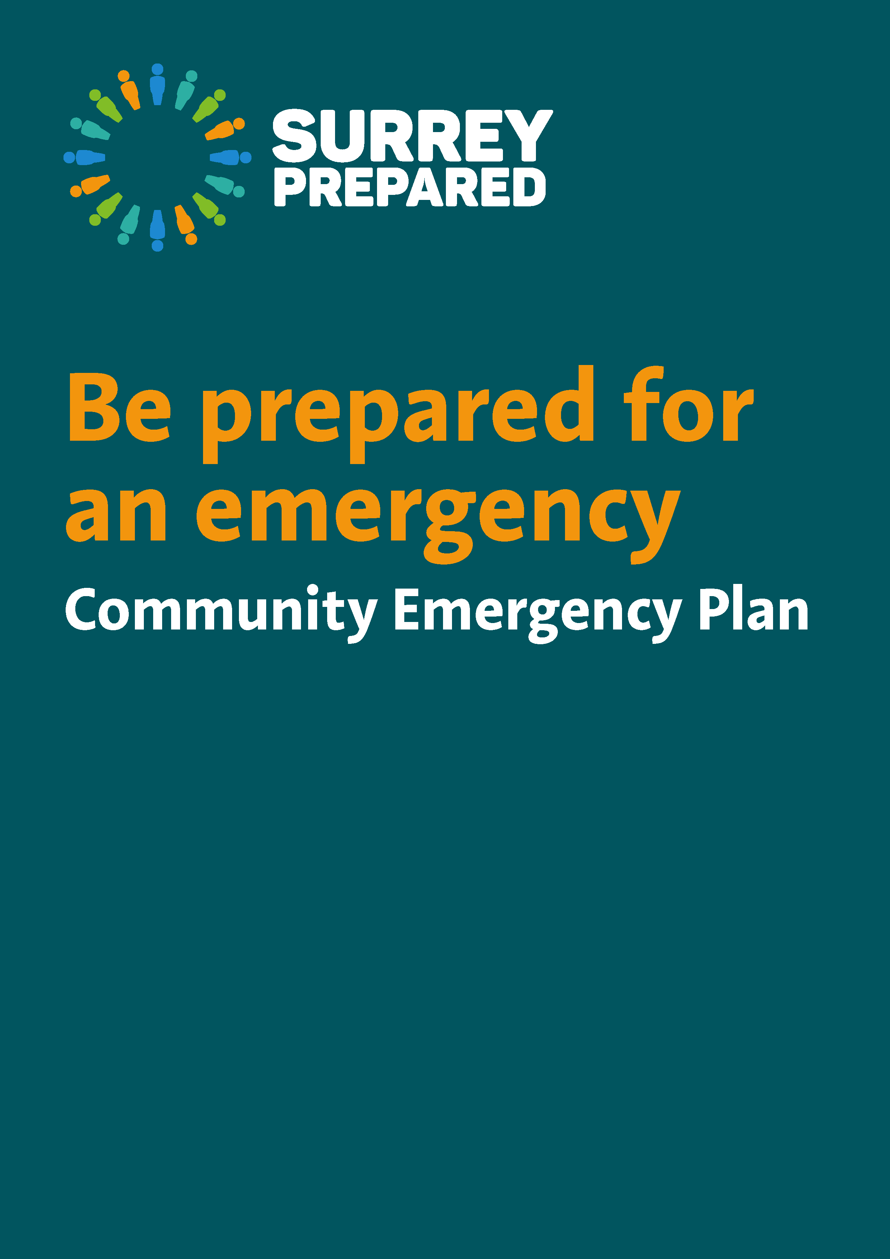

Contents

1 | Be informed | Page
1.1 | What is an emergency? | 3
1.2 | Agreed activation procedure and initial actions in an emergency | 4
1.3 | Local emergency responders and useful contacts | 5
2 | Get involved | 7
2.1 | Develop your local emergency register and action plan | 8
2.2 | Identify your community capacity, skills and resources | 9
3 | Additional resources | 11
 | Appendix A – Community emergency meeting agenda/minutes template | 12
 | Appendix B – Emergency log sheet template | 13
 | Appendix C – Situation Report template | 14
 | Appendix D – Issues log template | 15
 | Appendix E – Community mapping | 16

1. Be informed

1.1 What is an emergency?

An emergency, also referred to as incident, is anything that affects you, your family and/or your community.
Looking at Surrey’s profile including social, economic and geographical factors, the top risks in Surrey are as follows: pandemic flu, flooding, terrorism, severe weather, industrial accidents, heathland fires, transport accidents, animal health, and fuel shortages and utilities failure.
Emergency | Potential consequences
Pandemic Flu | - increase demand on health and social care services  - longer and more frequent disruptions to essential utilities  - reduced levels of emergency services cover  - disruptions to businesses and organisations through staff shortages and supply chain interruptions  - impacts on the national and local economy
Flooding | - disruption to utilities, electricity and water supplies  - evacuation of residents  - short, medium and long-term accommodation of those whose homes are flooded  - long-term psychological and health impacts  - impact on local businesses and the economy  - long-term restoration and recovery issues for homes and businesses
Terrorism | - road and travel disruption  - damage and disruption to utilities and infrastructure  - damage to property  - disrupt the ability of organisations to deliver essential functions to the community  - Serious violence against a person or a threat to a persons life (e.g. explosive devices, shootings and close quarter attacks, kidnappings or chemical, biological and radiological devices)  - Serious risk to the health and safety of the public
Severe weather (low temperatures and heavy snow, storms and gales, heatwaves) | - road and travel disruption  - damage and disruption to basic utilities  - damage to property  - disrupt the ability of organisations to deliver essential functions to the community
Industrial accidents | - impact to UK oil and gas supplies  - economic impacts through damage to local businesses  - long-term restoration and recovery of the local area  - contamination of crops and agricultural land.
Heathland Fires | - destruction of Sites of Special Scientific Interest and Areas of Outstanding Natural Beauty  - long-term restoration and recovery of wildlife habitat  - economic impacts through road and rail closures
Transport accident | - impact on local businesses through delayed or failed deliveries  - delays in emergency services reaching people
Utilities failure | - disruption to essential services and activities  - endangerment of vulnerable people  - financial impact on businesses  - civil unrest  - increased demand on emergency services  - travel disruptions  - disruption to businesses and normal home life

1.2 Agreed activation procedure and initial actions in an emergency

Emergency or notification of a potential emergency (e.g. via a member of the community, Environment Agency, local council, etc)
Is there an immediate threat to life
YES
NO
Call 999 unless already alerted
Does it warrant a community response?
- Notify and meet with other key community members
- Disseminate, assemble and collect local information by maintaining communication with the community to keep them informed and finding out about issues
- Inform your relevant district and borough councils that your community is mobilised and provide with details for the main point of contact
- Maintain contact with local authorities and emergency services to let them know what is happening and any emerging issues
- Log decisions and actions taken
- Refer to section 2.1. action plan to agree on a course of action within the community
- Identify relevant skills, capacity and resources using section 2.2
- Support those that may require additional help using Annexe 1 if appropriate
- Support emergency services and local authorities with their actions
YES
NO
- Disseminate, assemble and collect local information by maintaining communication with the community to keep them informed and finding out about issues

1.3 Local emergency responders and useful contacts

Who? | How to contact them? | What do they mainly do?
Police | Dial 999 in an emergency such as a crime in progress  For all non emergency Police reporting dial 101  Find out more: www.surrey.police.uk/ | Responding to incidents together with the other emergency services  The co-ordination of the emergency services, local authorities and other organisations during an emergency
Fire | Dial 999 in an emergency  Find out more: http://new.surreycc.gov.uk/people-and-community/surrey-fire-and-rescue | Responding to incidents together with the other emergency services  Fire-fighting and fire prevention  Detection, identification, monitoring and management of hazardous materials and protecting the environment
Ambulance & NHS | Dial 999 in an emergency  NHS non-emergency number: 111  Find out more: www.secamb.nhs.uk/ | Responding to incidents together with the other emergency services  Identify and alert the appropriate receiving hospitals Prioritise casualties
Surrey County Council | 03456 009 009 (8am-6pm weekdays)  SMS: 07527 182 861  Highways emergencies 03002001003  Adult and Children Social Care Emergency Duty Team 01483 517898 (6pm-8am weekdays and 24 hours a day on weekends and bank holidays)  Find out more: http://www.surreycc.gov.uk/ | Support the emergency services  Help the community recover  May take action to protect property from flooding by water from the highway where there is a failure of the highway drainage system  Help facilitate road closures and diversions
District and Borough Councils | Elmbridge Borough Council 01372 474474 and 01372 466114 out of hours  www.elmbridge.gov.uk  Epsom and Ewell Borough Council  01372 732000  www.epsom-ewell.gov.uk  Guildford Borough Council  01483 50 50 50  www.guildford.gov.uk/  Mole Valley District Council  01306 885001 and 01372 376533 out of hours  www.molevalley.gov.uk/  Reigate and Banstead Borough Council  01737 276000 and 07699 391689 out of hours  www.reigate-banstead.gov.uk  Runnymede Borough Council 01932 838383  www.runnymede.gov.uk/  Spelthorne Borough Council  01784 451499 and 01932 425060 out of hours  www.spelthorne.gov.uk/  Surrey Heath Borough Council  01276 707100  www.surreyheath.gov.uk  Tandridge District Council  01883 722000  www.tandridge.gov.uk  Waverley Borough Council  01483 523333 and out of hours 02392 242161  www.waverley.gov.uk  Woking Borough Council  01483 755855  www.woking.gov.uk | Support the emergency services  Help the community recover  - Help facilitate the provision of emergency accommodation  - Identify and set-up a safe place for community to stay after being evacuated - known as rest centre
Environment Agency | Incident hotline 0800 80 70 60 (24-hour service)  Floodline service 0345 988 1188 | Protect the environment and take reports of environmental pollution such as chemical or fuel spills, or many dead fish in rivers  Issue flood alerts and warnings to the public and implement flood defence where appropriate  Deal with emergency repairs and blockages on main rivers and own structures
Utility providers emergency numbers | Gas (National Grid) 0800 111 999  Power Cut - call 105 or visit www.powercut105.com to report power loss or damaged equipment or check who your regional distribution company is, or call your distribution company direct as below:  UK Power Networks 0800 316 3105 or 0333 323 2105  Scottish and Southern Electric Networks 0345 072 1905 or 0800 072 7282  Thames Water 0800 316 9800  South East Water 0333 000 0365  Affinity Water 0345 357 2407  Sutton and East Surrey Water 01737772000  British Telecoms 08001217667 | Support statutory responders  Ensure continuity of supply  Provide alternative means of supply during an emergency if there is a threat to life  In the case of water and power, have free services to support those who would suffer more in the event of supply interrupton – this is regional and so does not matter who the bills are paid to.
Animal Welfare (RSPCA) | 0300 1234 999 | Provide a twenty-four hour emergency service for injured, trapped, or stranded animals

Add your own local emergency contacts

In some cases, emergency services, local authorities and other organisations cannot deal with an emergency alone as part of their normal day-to-day activities. They will have to prioritise those in greatest need and/or may not be able to reach you immediately.
Community members can play an important role in reducing the impacts of an emergency on their community and complement the work of local emergency responders by planning and preparing for it. This can be achieved by producing a community emergency plan, keeping it up to date and exercising it on a regular basis (at least on a yearly basis). The plan details how to provide support to members of your community in a co-ordinated manner.

2. Get involved

- Develop your local emergency register and action plan
- Identify skills, capacity and resources (human, economic, infrastructure) in the community that will be available to assist during an emergency (including contact details)
- Develop and agree an activation procedure
- Encourage those who would benefit to sign up to the free Priority Register and Extra Care services from your regional electricity and fresh water suppliers (this is area based so it does not matter who they pay bills to) and to have a free fire safety check from the Surrey Fire Rescue Service.
Note that it is important to keep accurate, up-to-date records of information included in this document.

2.1 Develop your local emergency register and action plan

A local emergency register highlights the emergency you have identified that might impact on your community and agree the actions you will undertake if that risk emerges.

Emergencies | Potential/known impacts on community | What can you do to prepare? | What can you do to respond? | Resource  needed

2.2 Identify your community capacity, skills and resources
Introduction and Terms of Reference (Optional)
You may wish to set out your purpose in this box – for example “This community resilience group has been set up in case of any incident in Anytown in recognition that prepared communities are stronger and quicker to recover.” You may wish to include a short description of your group and any Terms of Reference or affiliation – such as being a subgroup of a Parish Council, Faith group or Residents Association or a stand alone group.
You could also include here any geographical limits of cover of the remit of the group.

Type of resource | Role | Contact Details | Other
town/village building, commercial accommodation – guest house or bed & breakfast, barns, public houses, outbuildings, church accommodation, equipment or personnel (doctors, nurses etc...), defibrillators, information board, local veterinary surgeon, boarding kennels, other local groups e.g. resident’s association, faith groups, neighbourhood watch, etc. | Catering, animal welfare, communication with the community, meeting room, key community members |  | Equipment: needs to be charged every 4 hours  Building: special facilities, access, keys to the building are being held by Mr X.  Hold a copy of the plan

It is recommended that the location the community chooses to co-ordinate the local activities includes but is not restricted to: Telephone, Internet, Photocopier, Kitchen, Toilets, Uninterrupted Power Supply, TV, radio, Maps, Hi-Viz jackets, Torches, candles, matches, First aid kit, Incident log sheets, food rations.

3. Additional resources

A number of additional templates have been created that you may want to use to help facilitate your community plan form, respond and recover from an emergency.

Appendix A – Community emergency meeting agenda/minutes template
During an emergency, it is important for key members of the community to meet early on in the incident and again on a regular basis to ensure a co-ordinated and effective local response. Appendix A could be used to support the running of these meetings.

Appendix B – Emergency log sheet template
In order to keep track of what’s going on you might be interested in using the emergency log sheet shown as appendix B to record every significant event and decision made/action taken. It may be useful to make photocopies of this page, so all key community members can have one at hand.

Appendix C – Situation report template
During an emergency and to facilitate the discussion with emergency services and local authorities, the situation report template could be used to enable them to gain a better idea of the situation and the resources required.

Appendix D – Issues log template
The issues log template can be used to record details of local issues where the community believe specific action is required in preparation for an emergency e.g. drainage maintenance and riparian ownership issues. It can also be used to record details of local issues during the response and recovery stages.

Appendix E – Community mapping
Having maps of your community may prove useful to help identify areas at risk, resources and those that may require additional help.

Annexe 1 (separate document) – Persons requesting special assistance
You may wish to compile a separate confidentially stored list of anyone who has come forward to request special assistance in an incident or emergency, such as help with evacuation or lifting items for example. This must not be shared except with responding agencies if requested in an emergency, and people listed must only be included with their own approval, and made aware the list will be shared if there is a need to protect life or welfare.

Appendix A – Community emergency meeting agenda/minutes template

Date:
Time: |  |  |  | Location
Attendees
1. | What is the current situation?
 | 1a | Location and timescale of the emergency. Is it near:  - A school?  - A vulnerable area?  - A main access route?
 | 1b | Type of emergency:  - Is there a threat to life?  - Has electricity, gas or water been affected?
 | 1c | Are there any vulnerable people involved?  - Elderly/infirm/disabled Families with children  - Non-English-speaking people.
 | 1d | What resources do we need?  - Food?  - Off-road vehicles?  - Blankets?  - Shelter?
2. | Establishing contact with the emergency services and local authority
3. | How can we support the emergency services and local authority?
4. | What actions can safely be taken
5. | Who is going to take the lead for the agreed actions?
6. | Any other issues?

Appendix B – Emergency log sheet template

Date | Time | Information/Decision/Action | Initials

Appendix C – Situation report template

Date |  |  |  | Time
Community |  |  |  | Report Number
Location of affected roads and suggested alternatives, main access points
Impact assessment
Area(s) |  | Electricity?  Yes/No | Gas?  Yes/No |  | Water?  Yes/No |  | Mobile phone coverage?  Yes/No
Details of people in need of additional assistance including emergency temporary accommodation
Community Resources in use
Community Resources available
Additional resource needed

Appendix D – Issues log template

Reference | Location | Description of Problem | Solutions Identified | Action Required | Open | Closed
01 | Philpot Lane roadside ditches | Ditches blocked leading to road flooding | Ditch owners to be identified | - organise regular community clean up day  - promote and encourage regular maintenance by owners

Appendix E – Community Mapping s)

Insert any relevant maps of the community here.

The Environment Agency has created a number of interactive maps to find out more about the environment you live in.

Surrey Interactive Map could also be used to view Ordnance Survey and A-Z maps of Surrey and view locational information overlaid on the map.

Notes

